Software Requirements Specification

for

English Dictionary

Version 1.0 approved

Prepared by

Nguyen Chau Thao Quan

Nguyen Hung Phuc

Nguyen Trung Ngoc

December 9, 2018

Table of Contents

1. Introduction 1

1.1 Purpose 1

1.2 Document Conventions 1

1.3 Definitions, Acronyms and Abbreviations 1

1.4 References 1

2. High Level Requirements 1

2.1 Product Perspective 1

2.2 Use Case Description 1

2.2.1 Diagram 2

2.2.2 User Description 6

2.2.3 Use Case Description 6

2.2.4 Use Case & User Permission Mapping 6

2.3 Operating Enviroment 6

2.4 Assumption and Dependencies 7

3. FUNCTIONAL REQUIREMENT 7

3.1 Module 01 7

3.1.1 UC01: Sign Up 7

3.1.2 UC02: Sign In 7

3.1.3 UC03: List of users 8

3.1.4 UC04: Account Personal Information 9

3.1.5 UC05: Search field 10

3.1.6 UC06: Language field 10

3.1.7 UC07: View History 11

3.1.8 UC08: Word Upload 11

4. Nonfunctional Requirements 12

4.1 Accessbility 12

4.2 Volume 12

4.3 Precision 12

4.4 Performance 12

4.5 Compatibility 12

4.6 Maintainability 12

4.7 Safety 12

4.8 Portability 13

5. System Constraint 13

5.1 Database 13

5.2 Device 13

5.3 Programming Language 13

Revision History

|  |  |  |  |
| --- | --- | --- | --- |
| **Name** | **Date** | **Reason For Changes** | **Version** |
|  |  |  |  |
|  |  |  |  |

# Introduction

## Purpose

This Software Requirement Specification version 1.0 provide a complete description of all the function and specification of the English dictionary project. This document is intended to sign the contract with the customer and to be used by the members of the software engineering team that will implement and verify the correct function of the system.

## Document Conventions

None

## Definitions, Acronyms and Abbreviations

|  |  |  |
| --- | --- | --- |
| **#** | **Abbreviation** | **Explaination** |
| 1 | SRS | Software Requirement Specification |
| 2 | UC | Use Case |
| 3 | SC | Screen |
| 4 | MS | Messages |

## References

|  |  |  |  |  |
| --- | --- | --- | --- | --- |
| **Title** | **Author** | **Version** | **Date** | **Source Location** |
|  |  |  |  |  |

# High Level Requirements

## Product Perspective

It is almost look like the common dictionary in real life, instead of buying them from bookstore, you need just access the dictionary web on the computer, when you enter any word, it will show you the meaning of that word, audio and the description.

## Use Case Description

### Diagram

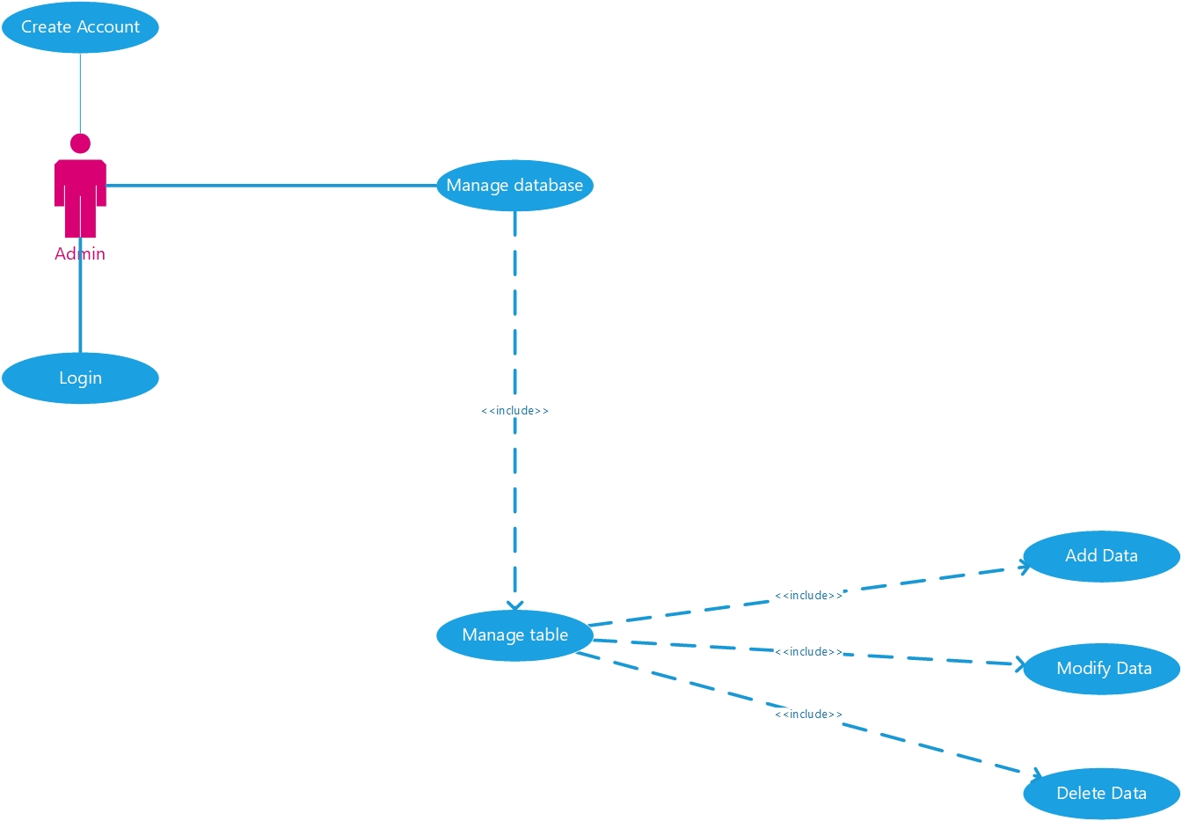

Diagram 1: Admin's Use Case

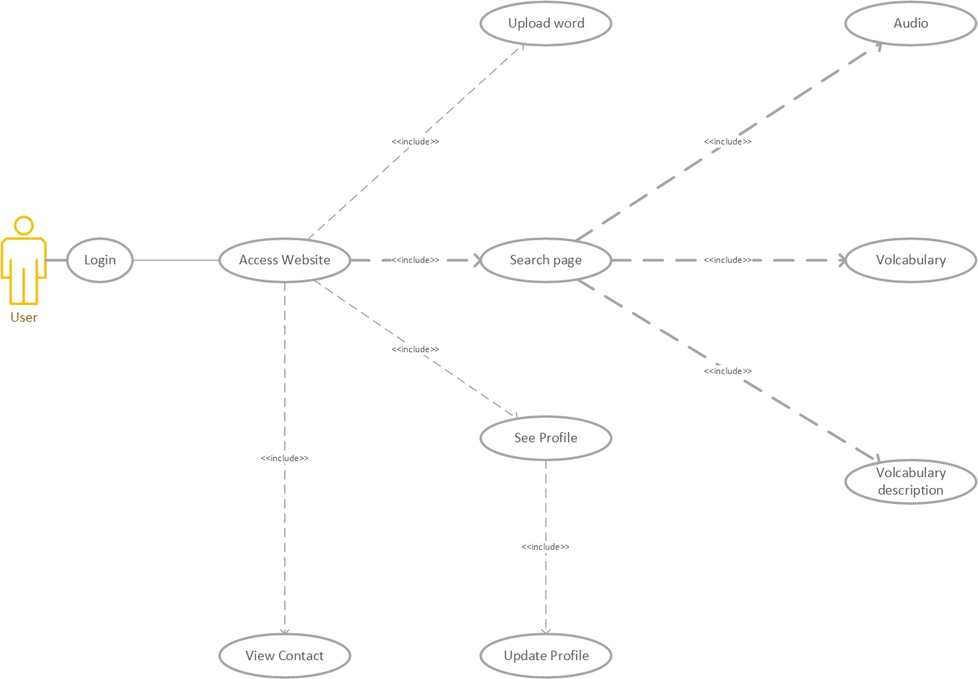

Diagram 2: User access Use case

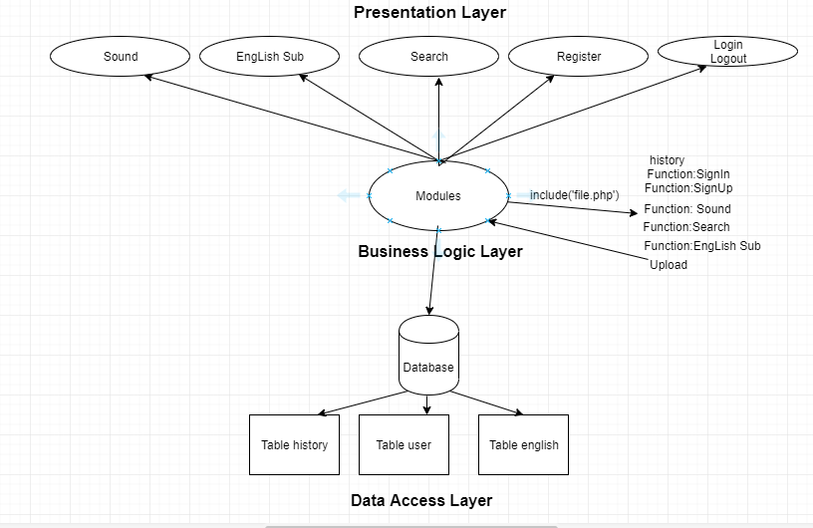

Diagram 3: Use case English Dictionary

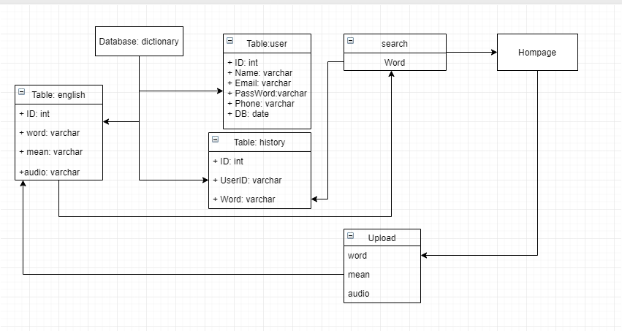

Diagram 4: Search and history, upload word

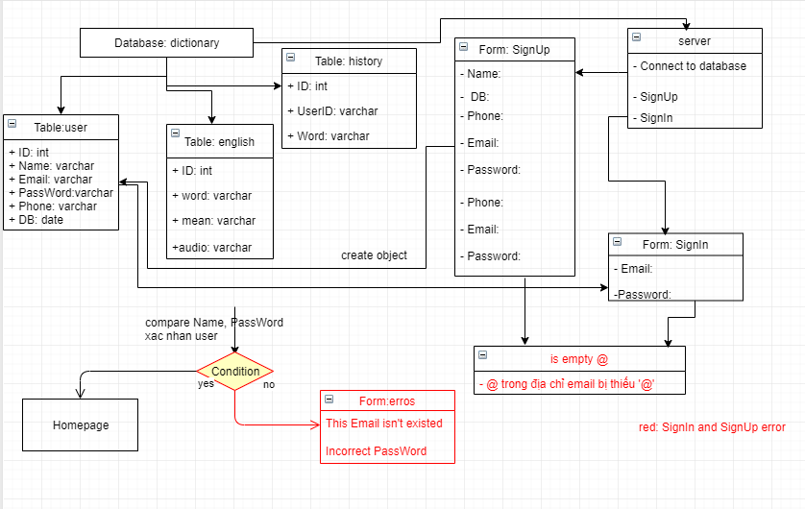

Diagram 5: SignIn, SignUp method

### User Description

|  |  |  |
| --- | --- | --- |
| **#** | **User Permission** | **Definition** |
| 1 | Admin |  |
| 2 | Account Manager |  |
| 3 | Guest |  |

### Use Case Description

|  |  |  |  |
| --- | --- | --- | --- |
| **#** | **ID** | **Name** | **Brief Description** |
| 1 | UC01 | Sign Up | User can create account to use the translate function |
| 2 | UC02 | Sign In | User can Login when they create account success |
| 3 | UC03 | List of user | Account Manager can see and manage the user account |
| 4 | UC04 | Account personal information | User can see and change their personal information |
| 5 | UC05 | Search field | User can enter the words or sentences to find the meaning |
| 6 | UC06 | Description section | User can see the word they enter and the meaning of that one |
| 7 | UC07 | Audio | User can hear the sound of that word |
| 8 | UC08 | View History | User can see the words they enter all the times |

### Use Case & User Permission Mapping

|  |  |  |  |  |
| --- | --- | --- | --- | --- |
| **Use Case** | **Use Case Name** | **Admin** | **Account Manager** | **Guest** |
| UC01 | Sign Up | X | X | X |
| UC02 | Sign In | X | X | X |
| UC03 | List of user | X | X |  |
| UC04 | Account personal information | X | X | X |
| UC05 | Search field | X | X | X |
| UC06 | Language field | X | X | X |
| UC07 | View History | X | X | X |
| UC08 | Upload Volcabulary | X | X | X |

## Operating Enviroment

## Assumption and Dependencies

# FUNCTIONAL REQUIREMENT

## Module 01

### UC01: Sign Up

|  |  |  |  |  |  |
| --- | --- | --- | --- | --- | --- |
| **ID** | **Name** | **Account** | **Trigger** | **Pre-condition** | **Post condition** |
| UC01 | Sign Up | Admin/Account Manager/Guest | User press the Sign Up button |  | Move to Sign Up form |

Activities

|  |  |  |  |
| --- | --- | --- | --- |
| **User** | | **System** | |
| Main flow: Sign Up Success | | | |
| 1 | User press sign up button. (SC01) |  | |
|  |  | 2 | Move to the Sign Up forms. (SC02) |
| 3 | User enter their name, email, password and tick the box I agree. |  |  |
|  |  | 4 | Validate the field and the check the password. |

System Messages

|  |  |
| --- | --- |
| MS01 | Please enter your name. |
| MS02 | Please enter your email. |
| MS03 | Please enter your password. |
| MS04 | The password is not matched. |
| MS05 | Cannot create account when the check box I agree is missing. |

### UC02: Sign In

|  |  |  |  |  |  |
| --- | --- | --- | --- | --- | --- |
| **ID** | **Name** | **Account** | **Trigger** | **Pre-condition** | **Post condition** |
| UC02 | Sign In | Admin/Account Manager/Guest | User press the Sign In button |  | Move to homepage |

**Activities**

|  |  |  |  |
| --- | --- | --- | --- |
| **User** | | **System** | |
| Main flow: Sign In Success | | | |
| 1 | User press sign in button (SC02) |  | |
|  |  | 2 | Move to the Sign Up forms (SC03) |
| 3 | User enter their name, email, password and tick the box I agree |  |  |
|  |  | 4 | Validate the field and the check the password. |

System Messages

|  |  |
| --- | --- |
| MS06 | Please enter your name This notification will appear when user let the name field is empty |
| MS07 | Please enter your email This notification will appear when user let the email field is empty |
| MS08 | Please enter your password  This notification will appear when user let the password field is empty |
| MS09 | The password is not matched  This notification will appear when 2 password from input isn’t same |
| MS10 | Cannot create account when the check box I agree is missing This notification will appear when user let the check box isn’t ticked |

### UC03: List of users

|  |  |  |  |  |  |
| --- | --- | --- | --- | --- | --- |
| **ID** | **Name** | **Account** | **Trigger** | **Pre-condition** | **Post condition** |
| UC03 | List of users | Admin/Account Manager | Admin/Account Manager press the icon user button |  | Move to List of users |

Activities

|  |  |  |  |
| --- | --- | --- | --- |
| **User** | | **System** | |
| Main flow: Move to List of User successful | | | |
| 1 | User press the icon (SC04) |  | |
|  |  | 2 | Show the list of users (SC05) |
| 3 | Admin/Account manager can lock or set the permission of account |  |  |

System Messages

|  |  |
| --- | --- |
| MS11 | Set up complete Admin/Account manager set the user permission successful |
| MS12 | Access denied Account isn’t admin or account manager can’t access when Admin/Account manager lock that one |

### UC04: Account Personal Information

|  |  |  |  |  |  |
| --- | --- | --- | --- | --- | --- |
| **ID** | **Name** | **Account** | **Trigger** | **Pre-condition** | **Post condition** |
| UC04 | Account Personal Information | Admin/Account Manager/Guest | User press the Account detail |  | Move to personal information page |

Activities

|  |  |  |  |
| --- | --- | --- | --- |
| **User** | | **System** | |
| Main flow: Sign Up Success | | | |
| 1 | User press personal information detail(SC06) |  | |
|  |  | 2 | Move to the personal information page (SC07) |
| 3 | User enter their new name, email, password. |  |  |
|  |  | 4 | Validate the field and the check the password by request their password again. |
| 5 | User enter the password to confirm |  |  |
|  |  | 6 | Notice when user type successful or not |

System Messages

|  |  |
| --- | --- |
| MS13 | Password is not match this message will appear when 2 password from user are not match |

### UC05: Search field

|  |  |  |  |  |  |
| --- | --- | --- | --- | --- | --- |
| **ID** | **Name** | **Account** | **Trigger** | **Pre-condition** | **Post condition** |
| UC05 | Search field | Admin/Account Manager/Guest | Admin/Account Manager/Guest enter any word or sentences and press search button. |  | Find the specific word to translate. Get data in Table(english) from database(dictionary) and user will see ‘Word, mean’ and listening ‘audio’. |

Activities

|  |  |  |  |
| --- | --- | --- | --- |
| **User** | | **System** | |
| Main flow: Search successful | | | |
| 1 | User enter the words or sentences. |  | |
|  |  | 2 | Check this is words or not Check this is sentences or not. |
| 3 | Translate from English to Vietnamese or vice versa. |  |  |

System Messages

|  |  |
| --- | --- |
| MS11 | This is not the words The word or sentence that user entered contain the special characters. |

### UC06: Language field

|  |  |  |  |  |  |
| --- | --- | --- | --- | --- | --- |
| **ID** | **Name** | **Account** | **Trigger** | **Pre-condition** | **Post condition** |
| UC06 | Language field | Admin/Account Manager/Guest |  |  | Translate a word or a sentence from English to Vietnamese or vice versa |

Activities

|  |  |  |  |
| --- | --- | --- | --- |
| **User** | | **System** | |
| Main flow: Search successful | | | |
| 1 | Enter a word which don’t have any special characters. |  |  |
|  |  | 2 | Translate this word from English to Vietnamese when user enter the word to search correct. |

### UC07: View History

|  |  |  |  |  |  |
| --- | --- | --- | --- | --- | --- |
| **ID** | **Name** | **Account** | **Trigger** | **Pre-condition** | **Post condition** |
| UC07 | View History | Admin/Account Manager/Guest | Admin/Account Manager/Guest click the view history button |  | See the word they looked up |

Activities

|  |  |  |  |
| --- | --- | --- | --- |
| **User** | | **System** | |
| Main flow: View History page | | | |
|  |  | 1 | Show the user the word history list |

### UC08: Word Upload

|  |  |  |  |  |  |
| --- | --- | --- | --- | --- | --- |
| **ID** | **Name** | **User** | **Trigger** | **Pre-condition** | **Post condition** |
| UC08 | Word Upload | All user can upload file audio, English… | User click the upload button in topbar menu |  | See the form of the upload page |

Activities

|  |  |  |  |
| --- | --- | --- | --- |
| **User** | | **System** | |
| Main flow: View Upload form | | | |
|  |  | 1 | Show form of the upload page ( include the word, audio link and html link). |

# Nonfunctional Requirements

## Accessbility

User enter 1 character and show the list of the words that have that character.

User can use their voice to fill the word automatically.

## Volume

Number of user can access at least 100 peoples.

## Precision

The word must be translated when the words or sentenced have uppercases in any location.

The word received from user’s voice must be filled corect.

Audio must be spoken correct depends on the description.

## Performance

The word that user look up show the result under 5s.

The web application is responsive.

## Compatibility

The application must run on web browser.

The application run on windows 7 or higher.

## Maintainability

The software is divided into several small modules so it is easy to upgrade and maintain.

All functions can be possibly colliped.

Add more functions when needed.

## Safety

The account management system will check the account activity when the bad behavior appear (pollitic, system security,…).

## Portability

The application run on device with any hardware:

* PC or laptop with minimum CPU core 2 duo, 2GB of rams or modern one.

# System Constraint

## Database

The application translate the word through firebase or MySQL.

## Device

The application run only on destop or laptop.

## Programming Language

Can write with the scripting language(HTML/CSS,JavaScript,PHP,...) or high level language (C/C++, python,java,...).

use modules through the command (unclude "../file.php";) in php.